Experiment 5
Student Name: Ranveer UID: 22BET10030
Branch: IT Section/Group: 22BET_703_A
Semester: 6 Date of Performance: 21-2-2025
Subject Name: Java Lab Subject Code: 22ITH-352

- Aim:
- Write a Java program to calculate the sum of a list of integers using autoboxing and unboxing. Include methods to parse strings into their respective wrapper classes (e.g., Integer.parseInt())..

- Objective:
- To Demonstrate Autoboxing and Unboxing
- To calculate sum of integers.

- Implementation/Code:
import java.util.ArrayList;
import java.util.List;

public class SumUsingAutoboxing {
public static void main(String[] args) {
String[] numbers = {"10", "20", "30", "40", "50"};
List<Integer> integerList = new ArrayList<>();
for (String num : numbers) {
integerList.add(Integer.parseInt(num)); // Autoboxing
}

int sum = calculateSum(integerList);
System.out.println("Sum of numbers: " + sum);
}
public static int calculateSum(List<Integer> list) {
int sum = 0;
for (Integer num : list) {
sum += num;
}
return sum;
}
}
- Output:
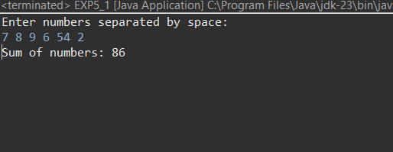

- Learning Outcome:
  - Learn how Java automatically converts between primitive types and their wrapper classes when adding/removing elements from collections
  - Gain experience in reading user input, splitting strings, and converting them into numerical values using Integer.parseInt().
  - Learn how to store user-provided integers in an ArrayList<Integer>, iterate through the list, and perform calculations using loops

Problem 2
- Aim:
Create a Java program to serialize and deserialize a Student object. The program should:Serialize a Student object (containing id, name, and GPA) and save it to a file.Deserialize the object from the file and display the student details.Handle FileNotFoundException, IOException, and ClassNotFoundException using exception handling.

- Objective:
- To Convert a Student object into a binary format and store it in a file
- To Retrieve the object from the file and reconstruct it using deserialization
- To implement the Serializable interface to allow objects to be written to and read from a file

- Implementation/Code:
import java.io.*;

class Student implements Serializable {
private static final long serialVersionUID = 1L; // Ensures compatibility during deserialization
int id;
String name;
double gpa;

public Student(int id, String name, double gpa) {
this.id = id;
this.name = name;
this.gpa = gpa;
}

// Display Student details
public void display() {
System.out.println("Student ID: " + id);
System.out.println("Name: " + name);
System.out.println("GPA: " + gpa);
}
}

public class StudentSerialization {
public static void main(String[] args) {
Student student = new Student(101, "Shuvam", 7.8);
String filename = "student.ser"; // File to store serialized object
serializeStudent(student, filename);
Student deserializedStudent = deserializeStudent(filename);
if (deserializedStudent != null) {
System.out.println("\nDeserialized Student Details:");
deserializedStudent.display();
}
}

public static void serializeStudent(Student student, String filename) {
try (ObjectOutputStream oos = new ObjectOutputStream(new FileOutputStream(filename))) {
oos.writeObject(student); // Serialize object
System.out.println("Student object serialized successfully.");
} catch (IOException e) {
System.out.println("Error during serialization: " + e.getMessage());
}
}

public static Student deserializeStudent(String filename) {
try (ObjectInputStream ois = new ObjectInputStream(new FileInputStream(filename))) {
return (Student) ois.readObject();
} catch (FileNotFoundException e) {
System.out.println("File not found: " + filename);
} catch (IOException e) {
System.out.println("Error during deserialization: " + e.getMessage());
} catch (ClassNotFoundException e) {
System.out.println("Class not found error: " + e.getMessage());
}
return null;
}
}

- Output:
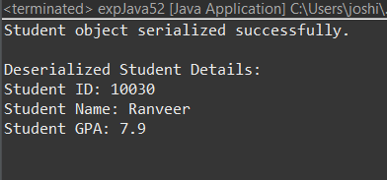

- Learning Outcome:
• Learn how to convert Java objects into a binary format for storage and retrieve them later while maintaining their state

• Gain hands-on experience in handling exceptions like FileNotFoundException, IOException, and ClassNotFoundException to ensure error-free file operations

• Learn how to implement the Serializable interface and use ObjectOutputStream and ObjectInputStream for efficient object persistence

Problem 3
- Aim:
- Create a menu-based Java application with the following options. 1.Add an Employee 2. Display All 3. Exit If option 1 is selected, the application should gather details of the employee like employee name, employee id, designation and salary and store it in a file. If option 2 is selected, the application should display all the employee details. If option 3 is selected the application should exit

- Objective:
- to read from and write to a file using FileWriter, BufferedWriter, and PrintWriter for storing and retrieving employee data.
- designing user-friendly menu-based applications using loops and switch cases for handling user choices.
- to take structured user input (such as integers, strings, and doubles) and process it correctly to avoid common input-related errors.

- Implementation/Code:
import java.io.*;
import java.util.Scanner;

public class EmployeeManagement {
private static final String FILE_NAME = "employees.txt"; // File to store employee data

public static void main(String[] args) {
Scanner scanner = new Scanner(System.in);
while (true) {
// Display menu
System.out.println("\nMenu:");
System.out.println("1. Add an Employee");
System.out.println("2. Display All Employees");
System.out.println("3. Exit");
System.out.print("Enter your choice: ");

int choice = scanner.nextInt();
scanner.nextLine(); // Consume newline

switch (choice) {
case 1:
addEmployee(scanner);
break;
case 2:
displayEmployees();
break;
case 3:
System.out.println("Exiting program...");
scanner.close();
System.exit(0);
default:
System.out.println("Invalid choice! Please enter 1, 2, or 3.");
}
}
}

// Method to add an employee and store details in a file
public static void addEmployee(Scanner scanner) {
try (FileWriter fw = new FileWriter(FILE_NAME, true);
BufferedWriter bw = new BufferedWriter(fw);
PrintWriter out = new PrintWriter(bw)) {

System.out.print("Enter Employee ID: ");
int id = scanner.nextInt();
scanner.nextLine(); // Consume newline

System.out.print("Enter Employee Name: ");
String name = scanner.nextLine();

System.out.print("Enter Designation: ");
String designation = scanner.nextLine();

System.out.print("Enter Salary: ");
double salary = scanner.nextDouble();

// Store details in file
out.println(id + "," + name + "," + designation + "," + salary);
System.out.println("Employee added successfully!");

} catch (IOException e) {
System.out.println("Error writing to file: " + e.getMessage());
}
}

// Method to display all employees by reading the file
public static void displayEmployees() {
try (BufferedReader br = new BufferedReader(new FileReader(FILE_NAME))) {
String line;
System.out.println("\nEmployee Details:");
while ((line = br.readLine()) != null) {
String[] data = line.split(",");
System.out.println("ID: " + data[0] + ", Name: " + data[1] +
", Designation: " + data[2] + ", Salary: " + data[3]);
}
} catch (FileNotFoundException e) {
System.out.println("No employee records found.");
} catch (IOException e) {
System.out.println("Error reading file: " + e.getMessage());
}
}
}

- Output:
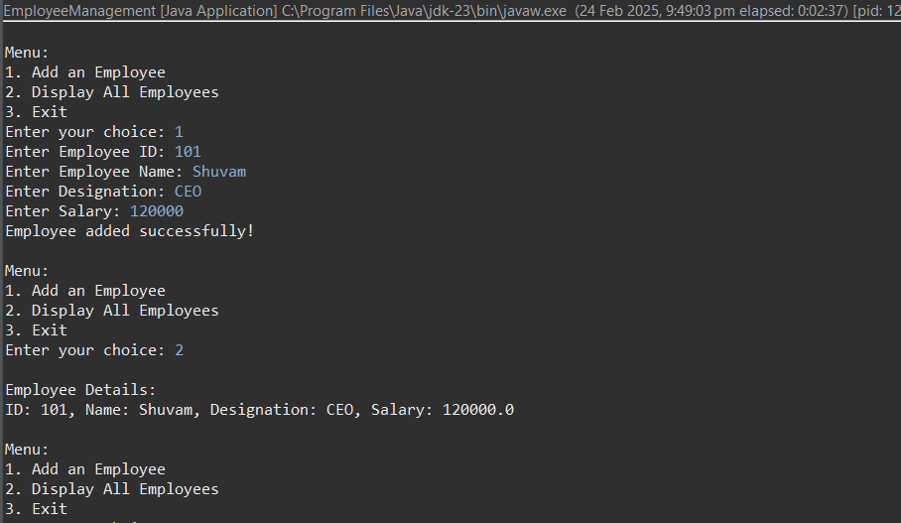

- Learning Outcome:
- Successfully read and write employee data to a file using FileWriter, BufferedReader, and PrintWriter.
- Learn to handle file-related exceptions such as IOException and FileNotFoundException, ensuring program stability
- Gain experience in storing structured employee data in a text file and retrieving it using string manipulation techniques like split()

